The Learning Game : Workshop n°7

Liège, Belgium
21th May 2008

Activity report

List of Participants

Christine Blaise (tutor) | INFOREF - Liège, Belgium
Christine Cloes | INFOREF - Liège, Belgium
Régine Smal | INFOREF - Liège, Belgium
Pierre Stegen | Collège Saint-Lambert - Herstal, Belgium
Georges Ferenc | Institut Marie-Thérèse - Liège, Belgium
Laurent Defoy | Institut de la Providence - Herve, Belgium
Mélanie Rahier | INPRES – Institut Provincial d’Enseignement Supérieur – Jemeppe, Belgium

Report

- Integration of 3D images and animations with Adventure Maker

We have now at our disposal a prototype of our game « FIREFLY ».
After the animation of introduction which explains the mission and leads the player to the caretaker’s office, the game can start. All the objects are operational : the player can take hold of them and place them in his/her stocklist. The explanatory texts are displayed on the screen either to identify the objects and their function in the game, or to guide the player in his/her action.

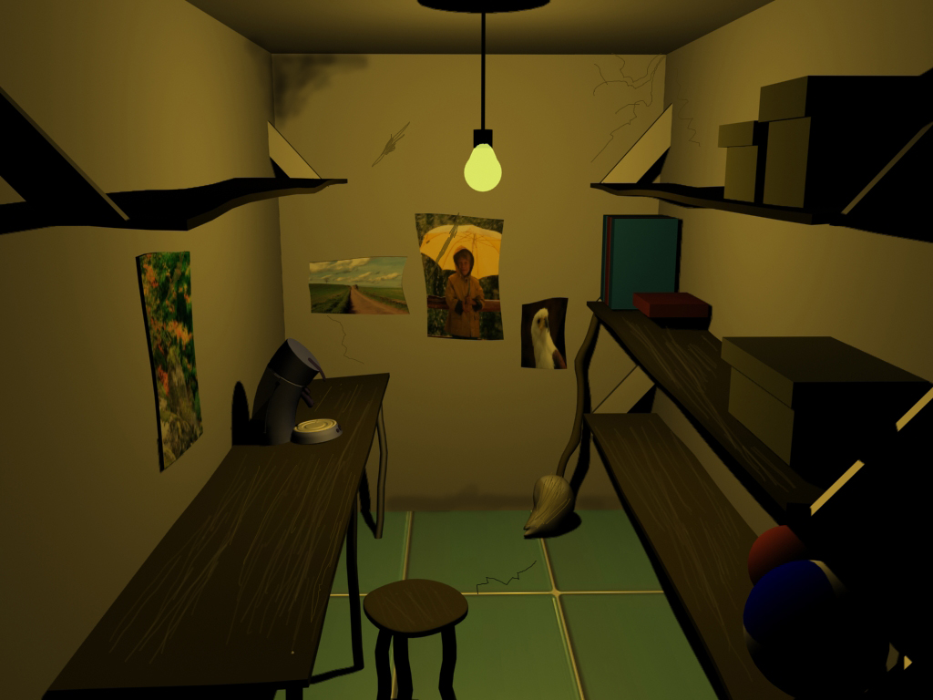
The visitor can move within the whole school : the fireflies didn’t invade all the rooms. That means that we have to search for energy loses at specific places such as the computing room, the sciences laboratory, the kitchen or the canteen…. The player can enter the rooms that didn’t propose any mission but that can bring some surprises….

Memorization of the completed actions in order to allow the player to come back in a room where he already achieved his/her mission and find back this room in the same state than when he left it, is a task still to be done (achieved mission or not). In the same way, getting back the fireflies into the bottle all along the game (when they are deprived of heat and turn back to their normal size) is also a task to be achieved

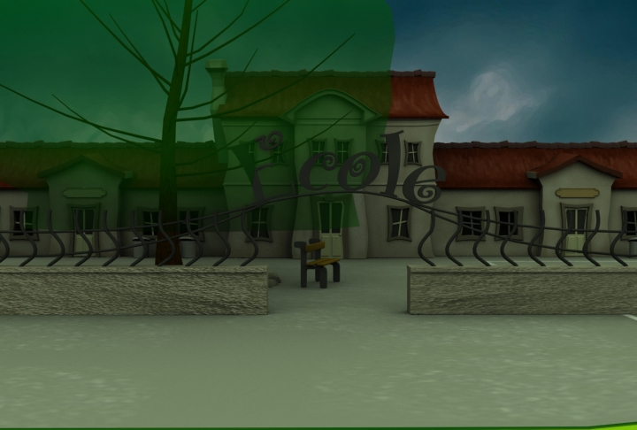

- Creation of explanatory texts and messages that will be integrated in the game.

The team has now achieved the texts that wil be used :

In the caretaker’s office

- Explanation on the fireflies
- Use of the objects gathered in the local
- In particular the thermic camera and the use of infrared thermography.
- The goal of the game : eliminating energy loses in order to turn the fireflies back to their normal size and to get them back to their bottle
- The electric consumption of the coffe machine that is off, but still plugged.

In the computing room

- The functioning of the thermostatic floodgate
- The heat loses due to not well shut windows
- The consumption of the computer which stayed on
- The consumption of the battery chargers which are plugged on the electricity network
- The usefullness of the multisockets adaptator

In the loboratory of siences

- The consumption and the dangers of a damaged electric cable
- The terrarium and the incubator

Some texts are still to be created

In the canteen

- The economic bulbs

In the kitchen

- Insulation of the fridge (watertightness joints)
- Defrosting of the freezer

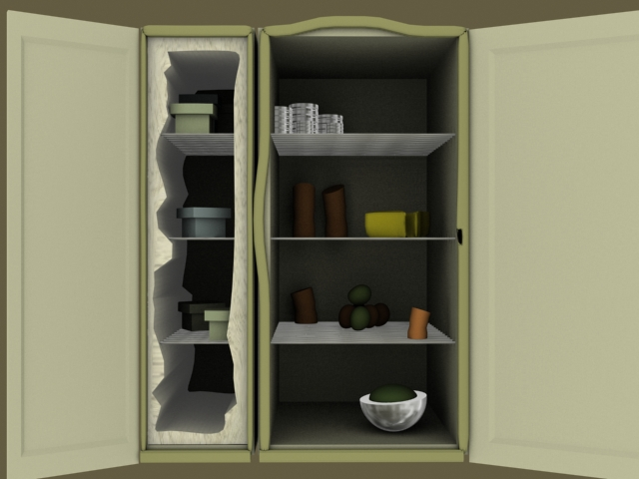

We also have to create an animation for the outcome of the game, the credits and the copyright, etc.



